LAB 4 TUTORIAL

This tutorial covers:
Chapter 5- Loops (Repetition Structure)

- Basic Multiple Choice and Subjective Question

- These are operators that add and subtract one from their operands.
A) plus and minus
B) ++ and --
C) binary and unary
D) conditional and relational
E) None of these
Answer: B

- What is the output of the following code segment?

n = 1;

while (n <= 5)
cout << n << ' ';
n++;

A) 1 2 3 4 5
B) 1 1 1... and on forever
C) 2 3 4 5 6
D) 1 2 3 4
E) 2 3 4 5
Answer: B

- This operator increments the value of its operand, then uses the value in context.
A) prefix increment
B) postfix increment
C) prefix decrement
D) postfix decrement
E) None of these
Answer: A

- The while loop has two important parts: an expression that is tested for a true or false value, and:
A) a statement or block that is repeated as long as the expression is true
B) a statement or block that is repeated only if the expression is false
C) one line of code that is repeated once, if the expression is true
D) a statement or block that is repeated once, if the expression is true
Answer: A

- A for statement contains three expressions: initialization, test, and
A) update
B) reversal
C) null
D) validation
E) None of these
Answer: A

- The do-while loop is a(n) ________ loop that is ideal in situations where you always want the loop to iterate at least once.
A) post-test
B) pre-test
C) infinite
D) null-terminated
E) None of these
Answer: A

- If you want a user to enter exactly 20 values, which loop would be the best to use?
A) do-while
B) for
C) while
D) infinite
E) None of these
Answer: B

- What will the following loop display?

int x = 0;
while (x < 5)
{
cout << x << endl;
x++;
}

A) 0
1
2
3
4
5

B) 0
1
2
3
4

C) 01 2 3 4

D) The loop will display numbers starting at 0, for infinity.
Answer: B

- What will the following code display?

int number = 6;
number++;

cout << number << endl;

A) 6
B) 5
C) 7
D) 0
Answer: C

- What will the following code display?

int number = 6;

cout << number++ << endl;

A) 6
B) 5
C) 7
D) 0
Answer: A

- Application Questions

- This program includes a while loop and uses a sentinel value to determine when the loop executes or when the loop is exited. Write a c++ expression and full program for the pseudocode as shown below:

start
num bankBal
num intRate
string response
print "Enter your starting balance... "
get bankBal
print "Enter your interest rate... "
get intRate
print "Do you want to see your current balance? Y or N . . ."
get response
while response = 'Y'
print "Bank balance is ", bankBal
bankBal = bankBal + bankBal * intRate
print "Do you want to see next year's balance? Y or N . . .")
get response
endwhile
print "Have a nice day!"
stop

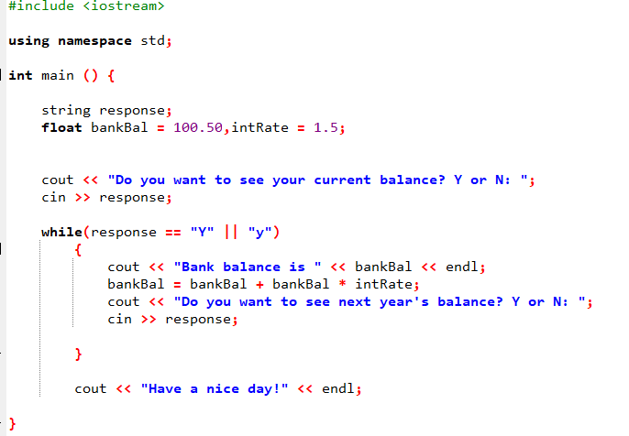
- Write a while loop and a do…while loop that have the same output. Given the following program segment using for loop:

for (number = 1; number <= 10; number++)
cout << setw (3) << number;

while loop:
int number =1;
while (number<=10) {
cout<<setw (3)<<number;
number++;
}

Do while:
int number =1;
do {
cout<<setw (3)<<number;
number++;
}
while (number<=10);

- Write a program that displays the elective courses menu and prompts the user to select from the menu using switch statement. The program will display the schedule for the chosen elective courses as in the table below. Use a do-while loop that repeats until the user want to exit from the menu.
Elective Courses | Schedule | Venue
Arts | Tuesday, 2.00pm - 4.00pm | Hall 1, School of Arts
Computer Sciences | Wednesday, 2.00pm - 4.00pm | Hall DKG31, School of CS
Mathematics | Tuesday, 3.00pm - 5.00pm | Hall DKG31, School of Mathematics
Accounting | Wednesday, 2.00pm - 4.00pm | Hall 23, School of Management

